**HOW TO USE THE CURSOR IN PACKAGE AND GIVE PERMISSION TO YOUR PACKAGE TO ANOTHER USER.**

CREATE OR REPLACE PACKAGE emp_cursor_pkg IS

CURSOR emp_cursor IS

SELECT employee_id, first_name, last_name, salary FROM employees;

PROCEDURE display_employees;

END emp_cursor_pkg;

/

CREATE OR REPLACE PACKAGE BODY emp_cursor_pkg IS

PROCEDURE display_employees IS

emp_record emp_cursor%ROWTYPE;

BEGIN

OPEN emp_cursor;

LOOP

FETCH emp_cursor INTO emp_record;

EXIT WHEN emp_cursor%NOTFOUND;

DBMS_OUTPUT.PUT_LINE('Employee ID: ' || emp_record.employee_id ||', First Name: ' || emp_record.first_name ||', Last Name: ' || emp_record.last_name ||', Salary: ' || emp_record.salary);

END LOOP;

CLOSE emp_cursor;

END display_employees;

END emp_cursor_pkg;

/

BEGIN

emp_cursor_pkg.display_employees;

END;

/

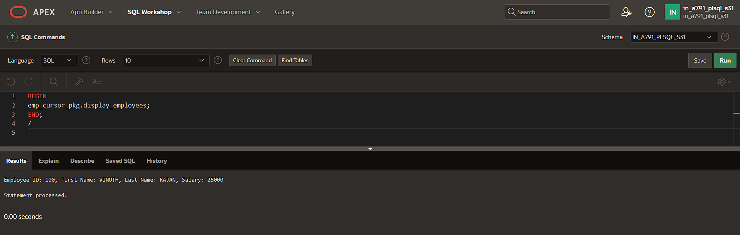

BEGIN

EXECUTE IMMEDIATE 'GRANT EXECUTE ON emp_cursor_pkg TO IN_A791_PLSQL_S28';

DBMS_OUTPUT.PUT_LINE('Privileges granted to IN_A791_PLSQL_S28.');

END;

/

